UNIVERSITÀ DEGLI STUDI DI MESSINA

Department of Mathematical, Computer, Physical and Earth Sciences

Bachelor's Degree in Data Analysis - 4th Year
Academic year 2025 - 2026

Subject: Software Engineering
Zemen: Dual-Calendar Collaborative Web Application
Software Engineering Final Project Report

Students:
Aklesia Berihu Mekonnen - 545854
Meron Zemichael Kahsay - 551795

Supervisor:
Prof. Salvatore Distefano

Table of Contents

1. Introduction……………………………………………………….4
2. General Existing Software Inspection and Motivation……………………………….5
3. Agile Methodology ………………………………………………………..7
3.1 Agile Manifesto – 4 Core Values ………………………………………………………..7
3.2 Agile Principles ………………………………………………………..7
3.3 Why Agile Over Plan-Driven ………………………………………………………..8
3.4 Different Types of Agile Methods ……………………………………………………….8
4. Scrum Overview ………………………………………………………..10
4.1 Scrum Roles ………………………………………………………..10
4.2 Scrum Artifacts ………………………………………………………..10
4.3 Why Scrum Over Other Agile Frameworks ………………………………………………………..10
4.4 Product Backlog ………………………………………………………..11
4.5 Product Refinement ………………………………………………………..12
4.6 How We Adhered to Scrum ………………………………………………………..13
5. Software Requirements Analysis ………………………………………………………..14
5.1 Functional Requirements ………………………………………………………..14
5.2 Non-Functional Requirements ………………………………………………………..18
5.3 Conceptual Architecture ………………………………………………………..19
6. Tools and Technologies ………………………………………………………..21
7. Sprint Development Overview ………………………………………………………..24
7.1 Sprint 1 – Foundation & Authentication ………………………………………………………..24
7.2 Sprint 2 – Date Conversion & Event CRUD ………………………………………………………..27
7.3 Sprint 3 – Collaboration & Scheduling Engine ……………………………………………………….. 31
7.4 Sprint 4 – Testing, Polish & Deployment ………………………………………………………..36
8. System Architecture ………………………………………………………..40
8.1 Three-Tier Architecture ………………………………………………………..40
8.2 Database Design ………………………………………………………..41
8.3 Deployment Architecture ……………………………………………………..42
9. UML Diagrams ………………………………………………………..44
10. Feature Implementation ………………………………………………………..50
11. Testing ………………………………………………………..54
12. Challenges and How We Solved Them ………………………………………………………..56
13. Conclusion ………………………………………………………..58
14. Future Plans ………………………………………………………..60

1. Introduction

Zemen meaning "era" or "time" in Amharic, is a full-stack collaborative web application that bridges two calendar systems: the Ethiopian (Ge'ez) calendar and the widely used Gregorian calendar. The name reflects the core idea of the project: bringing two distinct conceptions of time into a single, unified, and intuitive interface.

The Ethiopian calendar operates on a fundamentally different structure from the Gregorian one. It has 13 months: twelve of 30 days each and a thirteenth month (Pagume) of 5 or 6 days depending on the Ethiopian leap year cycle. Its New Year falls on September 11 or 12 in the Gregorian calendar, and the Ethiopian year runs approximately 7–8 years behind the Gregorian count. Managing dates, events, and collaborative scheduling across these two systems introduces genuine algorithmic complexity.

Zemen was proposed as a dual-calendar event management platform, but through the development process, and driven by the professor's challenge to go beyond basic CRUD functionality, it evolved into something significantly richer:

- A concurrent collaborative editing model using optimistic locking and version conflict detection, ensuring safe simultaneous edits by multiple users.
- A multi-stage smart scheduling engine based on interval merging, gap finding, candidate slot generation, and constraint-based ranking.
- A full field-level change-tracking system with immutable event snapshots, structured plain-text change summaries, and a visual diff viewer.
- Google OAuth 2.0 integration for authentication and Google Calendar export.
- Email reminder delivery via a background daemon thread with duplicate-prevention logging.

The system is deployed using Docker Compose, allowing the entire three-tier stack, React frontend, FastAPI backend, and PostgreSQL database, to launch with a single command. It is comprehensively tested with 116 Pytest unit tests (all passing) and 93 Postman integration tests (all passing).

This report documents the full software engineering journey of Zemen: the methodology we followed, every sprint in detail, the architecture and design decisions we made, the algorithms we implemented, the testing strategy we applied, and the lessons we learned.

2. General Existing Software Inspection and Motivation

Before writing a single line of code, we examined the landscape of existing calendar and scheduling tools to understand what they do well and where they fall short for our target users, Ethiopian students studying abroad, international teams collaborating with Ethiopian partners, and anyone who needs to plan around the Ethiopian calendar.

2.1 Problems in Existing Solutions

No Dual-Calendar Support
Every major calendar application, like Google Calendar, Apple Calendar, Outlook assumes the Gregorian calendar as the sole reference. There is no built-in support for the Ethiopian calendar. Users who need to track Ethiopian holidays, schedule around Timkat or Enkutatash, or communicate dates with Ethiopian partners must perform manual conversion every time.

No Integrated Conversion Tool
Standalone Ethiopian-Gregorian converters exist as simple web pages, but they are entirely disconnected from any scheduling or event management functionality. A user must convert a date in one tab, then manually enter it into a calendar in another, a fragmented workflow with high error risk.

No Collaborative Conflict Detection
Existing shared calendar tools do not expose version conflict information to users. When two people edit the same event simultaneously, one person's changes are silently overwritten. There is no version history, no field-level diff, and no notification to the losing editor.

No Constraint-Based Smart Scheduling Across Calendar Systems
Scheduling tools like Calendly or Doodle find available slots, but they operate entirely in the Gregorian system, have no awareness of Ethiopian public holidays, and provide no ranked output that explains why a slot is better or worse than another.

2.2 How Zemen Addresses These Gaps

Problem Identified | Zemen's Solution
No dual-calendar support | Native Ethiopian and Gregorian display; events stored in UTC, shown in either system on demand
No integrated conversion tool | Dedicated /convert endpoints and a Convert page in the UI
Silent overwrites in collaboration | Optimistic locking with version fields; 409 Conflict responses; field-level diff viewer
No smart scheduling across systems | Multi-stage scheduling pipeline with interval merging, gap finding, and constraint-based slot ranking
No Ethiopian holiday awareness | holidays table seeded with Ethiopian and Gregorian public holidays; treated as all-day busy blocks in scheduling

3. Agile Methodology

Zemen was developed using the Agile methodology. This section explains what Agile is, its core values and principles, why we chose it over alternative approaches, and the different Agile methods that exist.

3.1 Agile Manifesto – 4 Core Values

The Agile Manifesto, published in 2001, defines four core values that guide all Agile methodologies:

Value | We Value More | Over
1 | Individuals and interactions | Processes and tools
2 | Working software | Comprehensive documentation
3 | Customer collaboration | Contract negotiation
4 | Responding to change | Following a plan

In the context of Zemen, these values shaped our working style directly. We prioritised a working, deployable system at the end of each sprint over writing documentation first. When the professor asked us to extend the system with algorithmically richer features after Sprint 1, we responded to that change rather than strictly following the original plan.

3.2 Agile Principles

The Agile Manifesto defines 12 principles. The most relevant to our project were:

- Early and continuous delivery of working software: every sprint produced a runnable increment.
- Welcome changing requirements, even late in development: we added optimistic locking and the scheduling engine after Sprint 1 based on feedback.
- Working software is the primary measure of progress: we tracked progress by passing tests and deployed features, not by document completion.
- Simplicity, the art of maximising the amount of work not done is essential: we designed the schema in Sprint 1, and it held for the entire project without structural changes, a direct result of keeping it simple but correct.
- At regular intervals, the team reflects on how to become more effective: our sprint retrospectives identified the FastAPI header issue and the Postman version-staleness problem early.

3.3 Why Agile Over a Plan-Driven Approach

A plan-driven (Waterfall) approach would have required us to fully specify all requirements before writing code. For Zemen, this was not suitable for several reasons:

Dimension | Plan-Driven (Waterfall) | Agile (chosen)
Requirements | Fixed before development begins | Evolved sprint-by-sprint based on feedback
Change handling | Expensive; requires re-planning | Built-in: responding to change is a core value
Deliverables | Single large release at the end | Working increments every sprint
Risk | High - problems discovered late | Low - issues found and fixed within each sprint
Feedback loop | Long -professor sees output at the end | Short - professor could see running system each sprint
Team size fit | Better for large, distributed teams | Ideal for a 2-person student team

The professor's mid-project request to add collaborative features and a scheduling engine is precisely the kind of change that Agile accommodates naturally. Under Waterfall, this would have required restarting the design phase.

3.4 Different Types of Agile Methods

Agile is a family of methodologies. The main ones considered were:

Method | Description | Suitable For
Scrum | Time-boxed sprints, defined roles (PO, SM, Dev), fixed ceremonies | Projects with evolving requirements; team projects
Kanban | Continuous flow, work-in-progress limits, no fixed iteration length | Maintenance or operations work; single-person teams
XP (Extreme Programming) | Pair programming, TDD, continuous integration, frequent releases | High-quality code focus; pairs and small teams
SAFe | Scaled Agile for large enterprises with multiple teams | Large organizations: not suitable for student projects
Lean | Eliminate waste, deliver fast, decide as late as possible | Manufacturing-origin; generic process improvement

We chose Scrum, as detailed in the next section.

4. Scrum Overview

Scrum is an Agile framework for managing and completing complex projects. It organizes work into short, fixed-length iterations called sprints, typically 1–4 weeks long, with defined roles, ceremonies, and artifacts.

4.1 Scrum Roles

Role | Responsibility | In Zemen
Product Owner (PO) | Defines and prioritises the product backlog; represents stakeholder needs | Shared by both team members
Scrum Master (SM) | Facilitates the Scrum process; removes impediments; coaches the team | Rotated between Aklesia and Meron each sprint
Development Team | Self-organising team that delivers the sprint increment | Aklesia Berihu Mekonnen & Meron Zemichael Kahsay

4.2 Scrum Artifacts

Artifact | Description | Zemen Implementation
Product Backlog | Ordered list of all desired features and requirements | Maintained as a prioritised table covering all 16 deliverables
Sprint Backlog | Subset of the Product Backlog selected for the current sprint | Defined at the start of each sprint (see Section 7)
Increment | Working software delivered at the end of each sprint | Deployed via Docker Compose; tested via Pytest and Postman
Definition of Done (DoD) | Agreement on what 'complete' means for any item | Code written, tests passing, endpoint documented in Postman

4.3 Why Scrum Over Other Agile Frameworks

Criterion | Scrum | Kanban | XP
Iteration structure | Fixed sprints (ideal for project deadlines) | No fixed iterations | Fixed iterations
Planning ceremonies | Sprint planning, review, retrospective | Minimal | Extensive (pair programming, TDD)
Progress visibility | Burndown/burnup charts per sprint | Flow metrics | Velocity charts
Team size fit | 2–9 people (perfect for us) | Any size | Small teams
Learning curve | Moderate - clear structure | Low | High

Scrum's fixed sprint cadence was particularly valuable because it gave us a clear deadline and review point every week, preventing scope creep and keeping both team members synchronized.

4.4 Product Backlog

The full product backlog for Zemen, ordered by priority:

ID | User Story | Priority | Story Points | Sprint
PB-01 | As a user, I can register and log in securely | Must Have | 5 | 1
PB-02 | As a user, I can log in with my Google account | Must Have | 8 | 1
PB-03 | As a user, I can view and edit my profile and preferences | Must Have | 3 | 1
PB-04 | As a user, I can convert any date between Gregorian and Ethiopian | Must Have | 8 | 2
PB-05 | As a user, I can create, read, update, and delete calendar events | Must Have | 8 | 2
PB-06 | As a user, I can enter event dates in either calendar system | Must Have | 5 | 2
PB-07 | As a user, I can view Ethiopian and Gregorian public holidays | Should Have | 3 | 2
PB-08 | As a user, I can share events with others and assign roles | Must Have | 8 | 3
PB-09 | As an editor, my simultaneous changes are detected with version conflicts | Must Have | 13 | 3
PB-10 | As a user, I can see a field-level diff between two event versions | Should Have | 8 | 3
PB-11 | As an organiser, I can find the best meeting time for all participants | Must Have | 13 | 3
PB-12 | As a user, I can receive ranked time slot suggestions with scores | Should Have | 8 | 3
PB-13 | As a user, I receive email reminders before events | Should Have | 5 | 3
PB-14 | As a user, I can export an event to Google Calendar | Could Have | 5 | 4
PB-15 | All features are covered by Pytest unit tests (target: 100+) | Must Have | 8 | 4
PB-16 | All API endpoints are covered by Postman integration tests (target: 90+) | Must Have | 8 | 4

4.5 Product Refinement

Definition of Ready (DoR) for a Story
- The user story is written in standard format: As a [user], I can [action] so that [value].
- Acceptance criteria are defined and agreed upon by both team members.
- Dependencies on other stories or infrastructure are identified.
- The story has been estimated in story points using planning poker.

Definition of Done (DoD)
- Code is written and committed to the main branch.
- At least one Pytest test covers the feature's core logic.
- The relevant API endpoint is documented and passing in the Postman collection.
- The feature is manually verified, running in Docker Compose.

Cadence and Participants
Refinement sessions were held at the start of each sprint (Monday) and mid-sprint (Wednesday). Both team members participated. Each session lasted approximately 45–60 minutes.

4.6 How We Adhered to Scrum

Scrum Ceremony | Our Practice
Sprint Planning | Held at the start of each sprint; selected backlog items; estimated in story points; defined sprint goal
Daily Standup | Informal daily check-in between Aklesia and Meron: what did I do, what will I do? any blockers
Sprint Review | End-of-sprint demo of the running system; verified all DoD criteria; updated completion table
Sprint Retrospective | Identified what went well and what to improve; documented in each sprint section below
Backlog Refinement | Mid-sprint grooming to prepare upcoming stories; adjusted estimates based on lessons learned

5. Software Requirements Analysis

5.1 Functional Requirements

The following functional requirements were identified during Sprint 1 planning and refined throughout the project.

FR-1: User Registration and Authentication
Field | Detail
ID | FR-1
Description | Users must be able to register with an email and password and log in to receive a JWT access token valid for 60 minutes.
Acceptance Criteria | Registration stores bcrypt-hashed passwords. Login returns access_token. Unauthenticated requests receive 401.
Priority | Must Have
Implemented | Yes - /auth/register, /auth/login

FR-2: Google OAuth 2.0 Login
Field | Detail
ID | FR-2
Description | Users may authenticate via Google OAuth 2.0 as an alternative to email/password registration.
Acceptance Criteria | GET /auth/google/login-url redirects to Google. Callback at /auth/google/callback exchanges code for a token and creates or retrieves a user account.
Priority | Must Have
Implemented | Yes - /auth/google/* router

FR-3: User Profile Management
Field | Detail
ID | FR-3
Description | Users can view and update their profile, including full name, preferred calendar (Ethiopian or Gregorian), time zone, and language.
Acceptance Criteria | GET /profile returns current data. PUT /profile updates and returns the updated profile.
Priority | Must Have
Implemented | Yes - /profile router

FR-4: Ethiopian–Gregorian Date Conversion
Field | Detail
ID | FR-4
Description | The system must convert dates in both directions between the Ethiopian and Gregorian calendar systems, correctly handling the 13th month (Pagume), leap years, and New Year boundary dates.
Acceptance Criteria | GET /convert/g2e and /convert/e2g return correct converted dates. Pagume 6 is only valid in Ethiopian leap years. The New Year boundary (Sep 11 vs Sep 12) is correctly computed.
Priority | Must Have
Implemented | Yes - DataConversionService + /convert router

FR-5: Event CRUD
Field | Detail
ID | FR-5
Description | Authenticated users can create, list, retrieve, update, and delete calendar events. Events support simple recurrence (daily/weekly), full-text search, and date-range filtering.
Acceptance Criteria | POST /events creates. GET /events lists with optional filters. PUT /events/{id} updates with version. DELETE /events/{id} removes. All operations require authentication.
Priority | Must Have
Implemented | Yes - /events router

FR-6: Holiday Data Management
Field | Detail
ID | FR-6
Description | Public holidays for both calendar systems are stored and displayed. Users can create and delete custom holidays.
Acceptance Criteria | Default holidays are seeded at startup. GET /holidays lists all. POST /holidays creates a custom holiday. DELETE /holidays/{id} removes it.
Priority | Should Have
Implemented | Yes - /holidays router

FR-7: Shared Events with Role-Based Access
Field | Detail
ID | FR-7
Description | Event owners can share events with other users, assigning roles: owner, editor, or viewer. Role permissions are enforced at every relevant endpoint.
Acceptance Criteria | POST /events/{id}/share assigns participant and role. Editors can modify. Viewers receive 403 on modification attempts.
Priority | Must Have
Implemented | Yes - event_participants table + share endpoint

FR-8: Optimistic Locking and Version Conflict Detection
Field | Detail
ID | FR-8
Description | Each event carries a version integer. Update requests must include the current version. If another user has saved a newer version, the system returns a 409 Conflict response.
Acceptance Criteria | Submitting a stale version returns 409 with current_version and code: VERSION_CONFLICT. The correct version proceeds; version field increments; a snapshot is written.
Priority | Must Have
Implemented | Yes - version field in events table + conflict check in PUT /events/{id}

FR-9: Field-Level Diff and Version History
Field | Detail
ID | FR-9
Description | The system maintains an immutable snapshot of each event version. Users can request a structured field-level diff between any two versions.
Acceptance Criteria | GET /events/{id}/diff?from_version=X&to_version=Y returns changed fields with before/after values and a plain-text digest listing the changed field names.
Priority | Should Have
Implemented | Yes - event_snapshots table + DiffService

FR-10: Smart Scheduling — Interval Merging and Slot Ranking
Field | Detail
ID | FR-10
Description | Given a search window and duration, the system merges all participant busy intervals, finds free gaps, generates candidate slots, and ranks them by a penalty-based scoring function.
Acceptance Criteria | GET /events/{id}/rank returns ranked_slots sorted by score ascending. Required participant conflicts exclude the slot entirely. Optional participant conflicts add +100 penalty. Work-hours violations add +30 penalty.
Priority | Must Have
Implemented | Yes - IntervalService + RankingService

FR-11: Email Reminders
Field | Detail
ID | FR-11
Description | A background thread polls for events whose reminder window is approaching and sends an email via SMTP. Each reminder is logged to prevent duplicates.
Acceptance Criteria | Email is sent once per event reminder. Duplicate send is prevented by reminder_logs table. Thread runs as daemon and does not block application startup.
Priority | Should Have
Implemented | Yes - ReminderService (daemon thread)

FR-12: Google Calendar Export
Field | Detail
ID | FR-12
Description | Users with a connected Google account can push a Zemen event directly to their Google Calendar.
Acceptance Criteria | POST /google/export-event/{id} creates the event in the connected Google Calendar. Returns the Google Calendar event URL.
Priority | Could Have
Implemented | Yes - /google router

5.2 Non-Functional Requirements

ID | Category | Requirement | Implementation
NFR-1 | Security | Passwords must be hashed and never stored in plaintext | bcrypt hashing via passlib
NFR-2 | Security | JWTs must expire after a configurable period (default 60 min) | JWT expiry set in SecurityService
NFR-3 | Security | SQL injection must be prevented | All queries use SQLAlchemy ORM; no raw SQL strings
NFR-4 | Security | Role-based access must be enforced at every endpoint | Dependency injection checks role before each operation
NFR-5 | Reliability | The system must degrade gracefully if SMTP or Google OAuth are not configured | try/except guards around all external service calls
NFR-6 | Portability | The system must run on any machine with Docker installed | Full Docker Compose configuration with health checks
NFR-7 | Data Integrity | All event times must be stored in UTC | start_time_utc column; timezone applied only on output
NFR-8 | Testability | All core algorithms must have unit test coverage | 116 Pytest tests across conversion and scheduling
NFR-9 | Maintainability | Business logic must be separated from API routing | 6 service classes; routers stay thin
NFR-10 | Performance | Scheduling engine must complete within 2 seconds for typical inputs | Verified in Postman; average response 106ms

5.3 Conceptual Architecture

The conceptual architecture of Zemen is a three-tier client-server model, chosen for its clear separation of concerns, independent deployability of each tier, and proven suitability for web applications with multi-user access patterns.
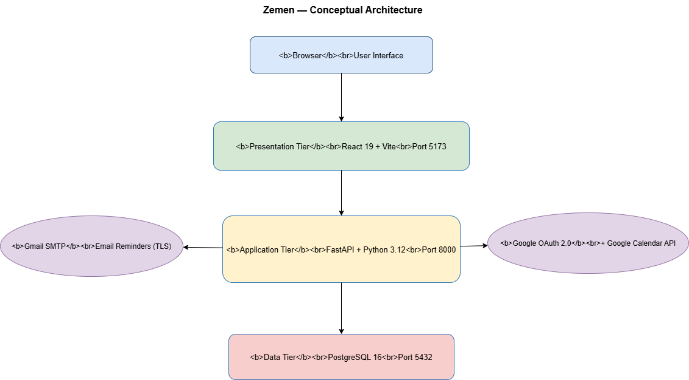
Figure 1: Zemen Conceptual Architecture - Three-tier client-server model
The three tiers interact as follows: the browser-based React client communicates exclusively with the FastAPI backend via HTTP/JSON. The backend contains all business logic and is the sole client of the PostgreSQL database. External services (Google OAuth 2.0 and SMTP) are called only by the backend, never directly by the frontend.

6. Tools and Technologies

6.1 Frontend Technologies

Technology | Version | Role | Why Chosen
React | 19 | UI component framework | Component model enables reusable calendar, form, and diff-viewer widgets; large ecosystem; team proficiency
Vite | 7 | Build tool and dev server | Significantly faster hot-reload than Create React App; native ES module support
React Router v7 | Latest | Client-side routing | Declarative routing with nested layouts; RequireAuth wrapper for protected routes
Fetch API (native) | Native | HTTP client | Used via custom api.js module; centralized token injection via authHeaders()

6.2 Backend Technologies

Technology | Version | Role | Why Chosen
FastAPI | Latest | Web framework | Python-native; automatic OpenAPI docs; async-ready; type-safe with Pydantic; excellent for API development
Python | 3.12 | Backend language | Strong ecosystem for date arithmetic and data manipulation; well-suited for algorithmic work (scheduling engine)
SQLAlchemy | 2.x | ORM | Prevents SQL injection; database-agnostic; clean model definitions; built-in relationship handling
Pydantic | v2 | Data validation | Request/response schema validation integrated with FastAPI; automatic 422 errors for malformed inputs
Passlib / bcrypt | Latest | Password hashing | Industry-standard; bcrypt's adaptive cost factor resists brute-force attacks
python-jose | Latest | JWT management | Simple, well-maintained; supports HS256 signing with configurable expiry
ethiopian_date | Latest | Calendar conversion | Core library for Ethiopian calendar arithmetic; extended with our own wrapper for edge cases
smtplib | stdlib | Email delivery | Standard library; no dependency overhead; TLS support built in

6.3 Database

Technology | Version | Role | Why Chosen
PostgreSQL | 16 | Primary database | ACID compliance essential for optimistic locking; rich data types; reliable at scale; strong SQLAlchemy support

6.4 DevOps and Infrastructure

Technology | Role | Why Chosen
Docker | Container runtime for all three tiers | Ensures identical environment on any machine; eliminates 'works on my machine' problems
Docker Compose | Multi-container orchestration | Single-command startup (docker compose up --build); service dependency management via health checks
Git | Version control | Full commit history; enables branch-per-sprint workflow

6.5 Testing Tools

Technology | Role | Coverage
Pytest | Unit and integration test framework | 116 tests: date conversion edge cases + full scheduling pipeline
Postman | API integration testing | 93 tests across 11 folders; fully rerunnable collection

6.6 External Services

Service | Role | Integration Point
Google OAuth 2.0 | User authentication and Google Calendar connection | /auth/google/* and /google/* routers
Google Calendar API | Export Zemen events to user's Google Calendar | POST /google/export-event/{id}
Gmail SMTP (TLS) | Email reminder delivery | ReminderService daemon thread; smtplib with TLS

7. Sprint Development Overview

Zemen was developed across four one-week sprints following the Scrum framework. Each sprint followed the standard Scrum cycle: Planning → Implementation → Testing → Review → Retrospective. This section documents every sprint in full detail.

7.1 Sprint 1 - Foundation and Authentication

1. Planning
Sprint Goal
Deliver a running three-tier application with user registration, login (email/password + Google OAuth), JWT-based authentication, profile management, and a correct database schema that will support the entire project without structural changes.

User Story: Secure User Authentication
Field | Detail
As a | new user
I want to | register with my email and password and log in to receive a secure token
So that | my data is protected and only I can access my events and profile
Acceptance Criteria | Registration hashes password with bcrypt. Login returns JWT. Unauthenticated requests return 401. Token expires after 60 minutes.
Story Points | 5

User Story: Google OAuth Login
Field | Detail
As a | user with a Google account
I want to | log in using Google OAuth 2.0 without creating a separate password
So that | I can access Zemen with a single click using my existing Google identity
Acceptance Criteria | Login URL endpoint redirects to Google. Callback creates/retrieves user. JWT is returned to frontend.
Story Points | 8

2. Implementation

Sprint Backlog
Item | Status | Owner
Design and create all six database tables | Done | Both
Set up Docker Compose (React + FastAPI + PostgreSQL) | Done | Aklesia
Implement /auth/register with bcrypt | Done | Meron
Implement /auth/login returning JWT | Done | Meron
Implement Google OAuth 2.0 login flow | Done | Aklesia
Implement /profile GET and PUT endpoints | Done | Both
Create Figma wireframes for all pages | Done | Meron

Major Achievements
- The full Docker Compose stack - React (port 5173), FastAPI (port 8000), PostgreSQL (port 5432) launched with a single command and passed health checks from day one.
- The database schema was finalized: users, events, event_participants, event_snapshots, holidays, reminder_logs. This schema held for the entire project with zero structural changes.
- Both authentication flows - email/password with bcrypt+JWT and Google OAuth 2.0 were implemented and tested.
- Figma wireframes were created for Calendar, Event Form, Convert, Settings, and Diff Viewer pages.

Challenges and Impediments
- Google OAuth configuration required correctly setting redirect URIs in the Google Cloud Console. An initial mismatch caused 400 errors during callback. Resolved by aligning GOOGLE_REDIRECT_URI in docker-compose.yml with the registered URI.
- FastAPI's automatic 422 validation conflicted with our initial login endpoint design. Resolved in Sprint 3 (see Section 8.3).

3. Testing
Sprint 1 testing focused on manual verification via Postman. Authentication endpoints (register, login, wrong password, and unauthenticated access) were tested manually and formed the basis of the 01-Authentication folder in the final Postman collection.

Figure 2: Sprint 1 - Docker Compose stack running successfully

4. Review
Key Deliverables and Metrics
Deliverable | Status | Notes
Docker Compose environment | Delivered | All three services pass health checks
Database schema (6 tables) | Delivered | No changes required in subsequent sprints
Email/password auth | Delivered | bcrypt + JWT; 60-minute expiry
Google OAuth 2.0 login | Delivered | Login and account creation flows working
Profile CRUD | Delivered | GET and PUT /profile endpoints
Figma wireframes | Delivered | All 5 pages wireframed

5. Retrospective
What Went Well
- Docker Compose setup was smooth. Having a reproducible environment from the first sprint eliminated environment-related debugging for the rest of the project.
- Database schema design was thorough. Including event_snapshots and reminder_logs from the beginning avoided painful migrations later.

What to Improve
- Google OAuth setup took longer than estimated. Future OAuth integrations should be allocated more time.
- Figma wireframes were created after implementation started rather than before. In Sprint 2 we reversed this order.

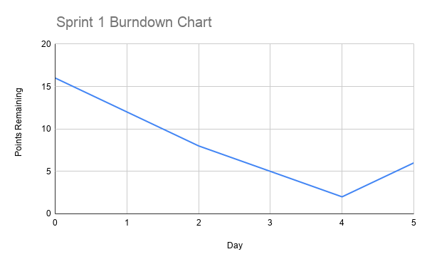
Figure 3: Sprint 1 Burndown Chart
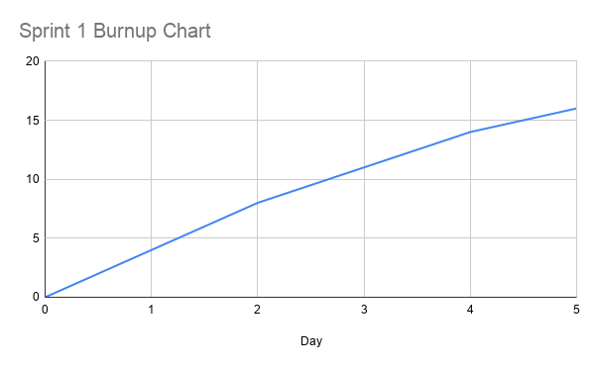
Figure 4: Sprint 1 Burnup Chart

7.2 Sprint 2 - Date Conversion Engine and Event CRUD

1. Planning
Sprint Goal
Deliver a correct, edge-case-tested Ethiopian–Gregorian conversion engine and a complete event management system with full CRUD, recurrence support, date-range filtering, and full-text search.

User Story: Date Conversion
Field | Detail
As a | user working across both calendar systems
I want to | convert any date from Gregorian to Ethiopian or vice versa with correct handling of the 13th month and leap years
So that | I can schedule events and communicate dates accurately in either system
Acceptance Criteria | Pagume 6 is valid only in Ethiopian leap years. New Year falls on Sep 12 in non-Gregorian-leap years, Sep 11 in Gregorian leap years. Round-trip conversion is lossless.
Story Points | 8

User Story: Event Management
Field | Detail
As a | registered user
I want to | create, view, update, and delete calendar events with support for Ethiopian or Gregorian dates, reminders, and recurrence
So that | I can manage my schedule across both calendar systems
Acceptance Criteria | All four HTTP verbs work. Events stored in UTC. Recurrence (daily/weekly) supported. Search and date-range filter work. Timezone conversion on output.
Story Points | 8

2. Implementation
Completed Backlog Items
Item | Status | Owner
ethiopian_date library integration and wrapper | Done | Aklesia
DataConversionService with Pagume and New Year edge cases | Done | Aklesia
GET /convert/g2e and /convert/e2g endpoints | Done | Aklesia
POST /events - create with UTC storage | Done | Meron
GET /events - list with search and date filter | Done | Meron
GET /events/{id} - retrieve single event | Done | Meron
PUT /events/{id} - update with version field | Done | Both
DELETE /events/{id} - remove event | Done | Meron
Holiday seed data and /holidays endpoints | Done | Aklesia
React Convert page and EventForm with calendar toggle | Done | Both

Major Achievements
- DataConversionService correctly handles all edge cases: Pagume 5 vs 6 days (Ethiopian leap year rule: year % 4 == 3), the New Year boundary (September 12 in non-Gregorian-leap years, September 11 in Gregorian leap years), and the 13-month Ethiopian year structure.
- Event CRUD system stores all times in UTC and converts to user timezone on output, ensuring time zone correctness regardless of where the user or server is located.
- The EventForm React page allows users to toggle between Gregorian (datetime-local input) and Ethiopian (year/month/day fields) date entry, with automatic conversion via the API before saving.

Challenges and Impediments
- Off-by-one errors in the New Year boundary calculation were caught through the round-trip parametrized Pytest tests added in Sprint 2. This validated the investment in test-first edge case thinking.
- Timezone handling initially double-converted some dates. Resolved by enforcing the rule: store UTC always, apply the timezone only on the way out to the client.

3. Testing
test_date_conversion_edge_cases.py was written this sprint: 16 tests covering New Year boundary dates, Pagume 5 vs 6 days, round-trip losslessness (6 parameterized date pairs), all 13 Ethiopian month names, and year-boundary cases.

Figure 5: Sprint 2 - Date Converter showing Gregorian → Ethiopian conversion

4. Review
Deliverable | Status | Notes
DataConversionService (full edge cases) | Delivered | 16 Pytest tests, all passing
GET /convert/g2e and /convert/e2g | Delivered | Included in Postman folder 03
Event CRUD (all 4 verbs) | Delivered | UTC storage; version field introduced
Ethiopian date entry in EventForm | Delivered | Calendar toggle works end-to-end
Holiday data and endpoints | Delivered | Ethiopian and Gregorian holidays seeded

5. Retrospective
What Went Well
- The decision to add parameterized round-trip tests immediately caught off-by-one errors that would have been very hard to debug later.
- The event version field was introduced in Sprint 2 even though optimistic locking was not fully implemented until Sprint 3 - this forward planning avoided a schema migration.

What to Improve
- The Convert page UI is functional but unstyled. Added to Sprint 4 polish backlog.

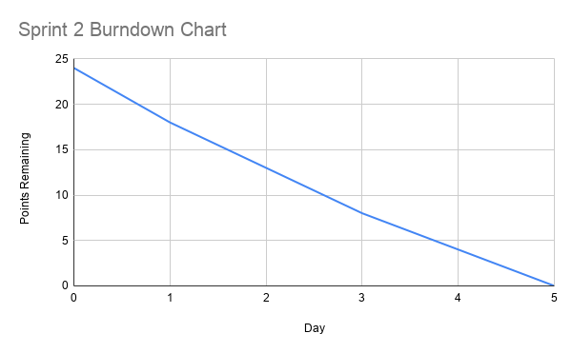
Figure 6: Sprint 2 Burndown Chart
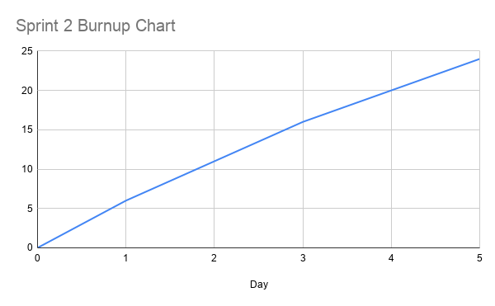
Figure 7: Sprint 2 Burnup Chart
7.3 Sprint 3 - Collaboration, Scheduling Engine, and Reminders
1. Planning
Sprint Goal
Deliver the full collaborative event system (role-based sharing, optimistic locking, version conflict detection, field-level diff), the multi-stage smart scheduling engine (interval merging, gap finding, constraint-based slot ranking), and the email reminder daemon.

User Story: Collaborative Event Editing with Conflict Detection
Field | Detail
As a | shared event editor
I want to | be notified when my save would overwrite someone else's concurrent changes, and be shown exactly what changed
So that | no data is silently lost and I can make an informed decision about whether to force-save or discard my changes
Acceptance Criteria | Stale version returns 409 with VERSION_CONFLICT code. GET /events/{id}/diff returns field-level changes with from/to values. Frontend shows conflict message with options to review diff or force-save.
Story Points | 13

User Story: Smart Scheduling
Field | Detail
As an | event organiser with multiple participants
I want to | get ranked suggestions for the best meeting time that avoids everyone's conflicts
So that | I can quickly schedule a meeting without manually checking each participant's calendar
Acceptance Criteria | GET /events/{id}/rank returns slots sorted by score. Required participant busy = slot excluded. Optional participant busy = +100 score. Outside work hours = +30 score. Earlier slots score better.
Story Points | 13

2. Implementation
Completed Backlog Items
Item | Status | Owner
POST /events/{id}/share - role assignment | Done | Meron
Role permission enforcement at all endpoints | Done | Meron
Optimistic locking - version check on PUT | Done | Aklesia
EventSnapshot model and write-on-update logic | Done | Aklesia
DiffService - field-level comparison with structured change digest | Done | Aklesia
GET /events/{id}/diff endpoint | Done | Aklesia
IntervalService - normalize, merge, find gaps | Done | Both
RankingService - candidate generation + penalty scoring | Done | Both
GET /events/{id}/rank endpoint | Done | Both
ReminderService - daemon thread + duplicate prevention | Done | Meron
EventDiff React page | Done | Aklesia
Ranked slots panel in EventForm | Done | Both

Major Achievements
- The optimistic locking implementation is production-grade: every update atomically checks and increments the version field, and the 409 response includes enough information (current_version, your_version) for the client to offer a meaningful recovery path.
- The DiffService compares snapshots field by field and produces a plain-text digest listing the changed field names (e.g. “Changes: title, reminder_minutes”). providing a concise, auditable record of each change set, analogous to the change history in Google Docs.
- The scheduling pipeline (IntervalService → merge → gaps → slots → RankingService) correctly handles: participants with no events (zero busy intervals), fully blocked windows (empty result), gaps shorter than the requested duration (skipped), and holidays as all-day busy blocks.
- The ReminderService runs as a daemon thread, polls every 10 seconds, and uses the reminder_logs table to guarantee at-most-once delivery even across server restarts.

Challenges and Impediments
- Merging overlapping and touching intervals (e.g., (09:00, 10:30) and (10:30, 11:00)) required careful boundary handling. The merge function was refined after test failures revealed a touching-but-non-overlapping edge case.
- Holiday integration into the scheduling engine required extending busy_intervals_for_user to call holiday_intervals and prepend them before merge_intervals. This was an unplanned but necessary design change identified during Sprint 3 testing.

3. Testing
test_scheduling_pipeline.py was written this sprint: 15 tests covering two-user conflict scenarios, fully-blocked windows, required vs optional participant handling, sort-order guarantees, role permission checks, and fragmented interval merging.

Figure 8: Sprint 3 - Ranked time slot suggestions in the Event Form

Figure 9: Sprint 3 - Event Diff Viewer showing field-level change history

4. Review
Deliverable | Status | Notes
Role-based event sharing | Delivered | owner/editor/viewer enforced at all endpoints
Optimistic locking + 409 Conflict | Delivered | VERSION_CONFLICT with current_version in response
Field-level diff (DiffService) | Delivered | Structured plain-text change digest included
IntervalService (merge + gaps) | Delivered | Handles all edge cases
RankingService (candidates + scoring) | Delivered | Penalty table: required=exclude, optional=+100, off-hours=+30
ReminderService (daemon thread) | Delivered | At-most-once delivery via reminder_logs
EventDiff React page | Delivered | Accessible from calendar and conflict dialog

5. Retrospective
What Went Well
- Sprint 3 was the most technically demanding sprint and everything was delivered. The algorithmic work on the scheduling pipeline, particularly the penalty-based ranking, produced results that feel genuinely useful, not just technically correct.
- The test suite grew substantially this sprint. Having tests for the scheduling pipeline made refactoring the holiday integration straightforward.

What to Improve
- The EventDiff page UI is minimal. Added to Sprint 4 polish list.
- The ranked slots panel in the EventForm only shows slot times and scores, not participant-level detail. A future improvement would show which participants are busy for each slot.
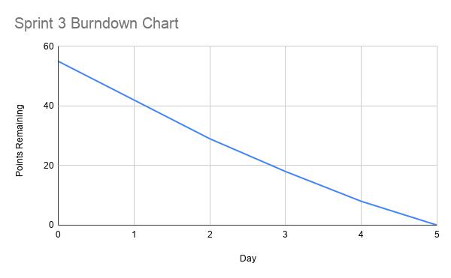
Figure 10: Sprint 3 Burndown Chart
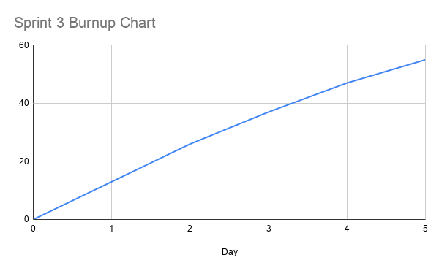
Figure 11: Sprint 3 Burnup Chart

7.4 Sprint 4 - Testing, UI Polish, and Docker Deployment
1. Planning
Sprint Goal
Reach comprehensive test coverage (116 Pytest + 93 Postman), polish the UI across all pages, finalize Docker Compose deployment, generate all UML diagrams, and write the project report.

User Story: Comprehensive Test Coverage
Field | Detail
As the | project team
We want to | achieve full coverage of all algorithms and all API endpoints with automated tests
So that | we can confidently demonstrate the system's correctness and reliability
Acceptance Criteria | 116 Pytest tests all pass. 93 Postman tests all pass. Postman collection is rerunnable (timestamp email, live version fetch).
Story Points | 8

2. Implementation
Completed Backlog Items
Item | Status | Owner
Extend Pytest suite to 116 tests | Done | Both
Build Postman collection (93 tests, 11 folders) | Done | Both
Add Date.now() timestamp to Postman registration for rerunnability | Done | Meron
Add pre-request script for live version fetch in Postman | Done | Meron
UI polish: Calendar, EventForm, Convert, Settings pages | Done | Aklesia
Generate 6 PlantUML diagrams and 2 use case diagrams | Done | Both
Verify Docker Compose full build from clean state | Done | Aklesia
Write project report | Done | Both

Major Achievements
- The Postman collection was made fully rerunnable: the registration request uses Date.now() in the email address to avoid duplicate registration errors, and the Update Event request uses a pm.sendRequest pre-request script to fetch the current version before every run.
- The FastAPI login header issue (credentials sent as JSON body vs query parameters) was identified and corrected. The login endpoint takes email and password as query parameters, not a JSON body. This was the root cause of a cascade failure in the early Postman collection.
- All 116 Pytest tests pass. All 93 Postman tests pass. Average API response time: 106ms.

Challenges and Impediments
- The Postman version-staleness problem: the initial Update Event request sent a hardcoded version number that became stale after the first run. Solved with the pre-request script.
- The FastAPI header validation issue: the login endpoint was sending a JSON body to a query-parameter endpoint, causing 422 errors and silent token failures in all downstream tests. Required careful debugging of the response chain.

3. Testing
Figure 12: Sprint 4 - Full Pytest run showing 116 tests passing
Figure 13: Sprint 4 - Postman Collection Runner showing all 93 tests passing

4. Review
Deliverable | Status | Notes
116 Pytest tests | Delivered | All passing; 0 failures; 7.43s runtime
93 Postman tests (11 folders) | Delivered | All passing; avg 106ms response time; fully rerunnable
UI polish across all pages | Delivered | Calendar, EventForm, Convert, Settings, Diff Viewer
6 UML diagrams (PlantUML) | Delivered | Class, 4× Sequence, Component
Docker Compose clean build | Delivered | Full rebuild from scratch verified
Project report | Delivered | This document

5. Retrospective
What Went Well
- The rerunnable Postman collection is a genuine quality artifact - it can be run against any deployed instance of Zemen and will produce a full pass/fail report without any manual setup.
- The decision to introduce the version field in Sprint 2 and build the snapshot mechanism in Sprint 3 meant there was nothing to retrofit in Sprint 4.

What to Improve
- Report writing took longer than expected and should be allocated its own sprint backlog item with a story point estimate from the beginning.
- The UI could benefit from a proper design system (Tailwind CSS or a component library). Currently styled with inline CSS which is functional but not scalable.

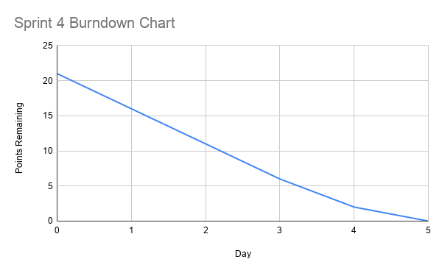
Figure 14: Sprint 4 Burndown Chart
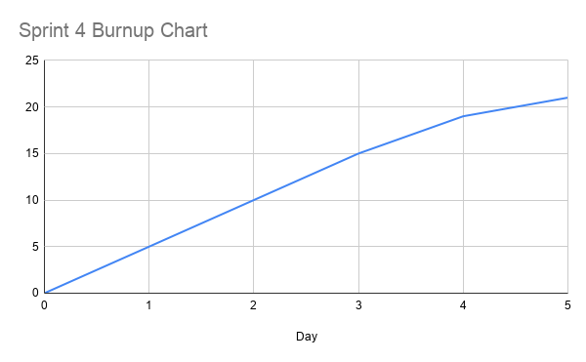
Figure 15: Sprint 4 Burnup Chart

8. System Architecture
8.1 Three-Tier Web Architecture

Zemen follows a strict three-tier architecture: Presentation (React frontend), Application (FastAPI backend), and Data (PostgreSQL database). This separation of concerns means each tier can be developed, tested, and scaled independently.

Tier | Technology | Port | Responsibility
Presentation | React 19 + Vite | 5173 | Renders the UI; handles routing; stores JWT in localStorage; attaches Bearer token to every authenticated request via authHeaders()
Application | FastAPI (Python 3.12) | 8000 | All business logic; 8 focused routers; 6 service classes; JWT validation; role enforcement; external service calls
Data | PostgreSQL 16 | 5432 | Persistent storage for all application data; 6 tables; ACID-compliant transactions for optimistic locking

Frontend Routing
The React frontend uses React Router v7 with a RequireAuth wrapper component that redirects unauthenticated users to /login. The authenticated routes are:

Route | Component | Purpose
/ | Calendar | Month-view calendar grid with event display, create, edit, delete
/convert | Convert | Date conversion in both directions with result display
/settings | Settings | Profile viewing and editing (preferred calendar, timezone, language)
/events/new | EventForm | Create a new event (Gregorian or Ethiopian date input)
/events/:id/edit | EventForm | Edit existing event with version display and ranked slot suggestions
/events/:id/diff | EventDiff | View field-level diff between any two event versions

Backend API Structure
The FastAPI backend is organized into 8 routers, each handling its own domain, with business logic extracted into service modules:

Router | Prefix | Key Endpoints | Service
auth | /auth | register, login, google/login-url, google/callback | SecurityService
profile | /profile | GET, PUT /profile | —
events | /events | CRUD, /share, /participants, /diff, /conflicts, /suggest, /rank | IntervalService, RankingService, DiffService
conversion | /convert | g2e, e2g | DataConversionService
scheduling | (events) | /suggest, /rank | IntervalService, RankingService
diff | (events) | /diff | DiffService
holidays | /holidays | GET, POST, DELETE | —
google | /google | status, connect-url, export-event/{id} | —

8.2 Database Design

The data model was designed in Sprint 1 and required zero structural changes throughout the project, a testament to the upfront schema planning.

Table | Purpose | Key Fields
users | User accounts, preferences, OAuth tokens | id, email, hashed_password, preferred_calendar, timezone, google_access_token, google_refresh_token
events | Core event data stored in UTC | id, user_id (FK), title, description, start_time_utc, end_time_utc, timezone, version
event_participants | Role-based sharing junction table | id, event_id (FK), user_id (FK), role (owner|editor|viewer)
event_snapshots | Immutable audit trail - one row per version | id, event_id (FK), version, title, description, start_time_utc, end_time_utc, timezone, reminder_minutes
holidays | Ethiopian and Gregorian public holidays | id, name, eth_year/month/day, resolved_date, calendar_type
reminder_logs | Sent reminder records for duplicate prevention | id, event_id (FK), recipient_email, sent_at

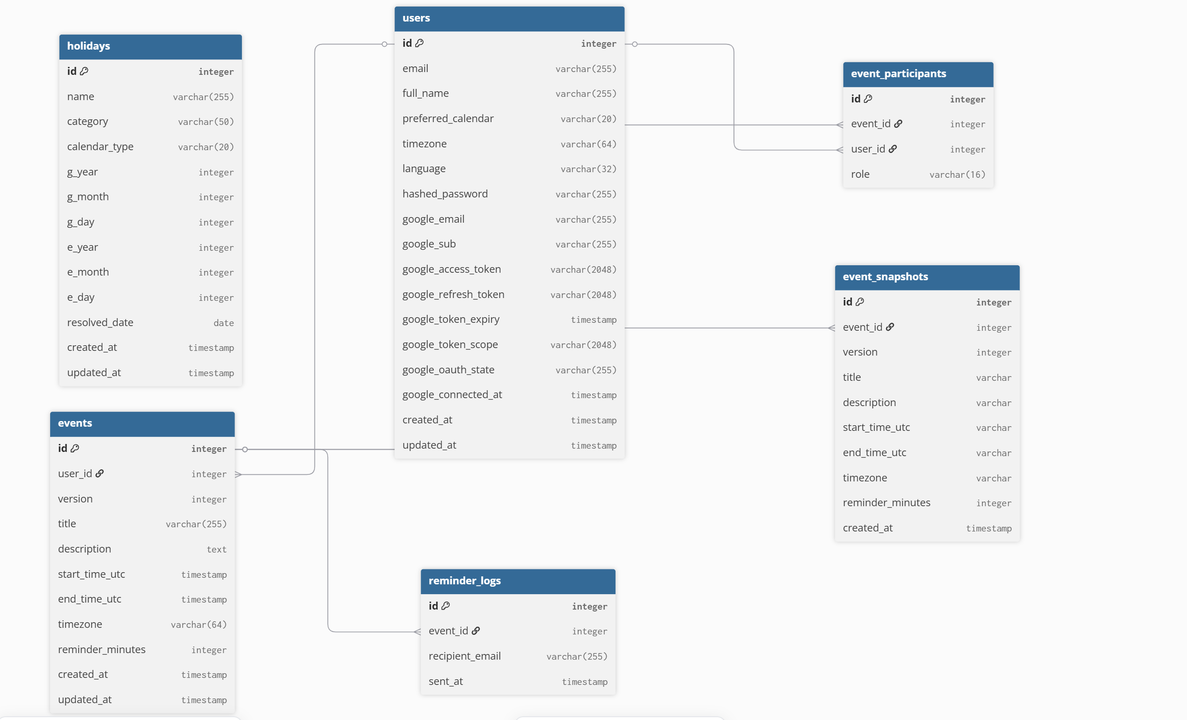
Figure 16: Zemen Database Entity-Relationship Diagram

8.3 Deployment Architecture

The entire system is containerized using Docker Compose. Each tier runs in its own container, connected via Docker's internal network. The database uses a named volume (pgdata) for data persistence across container restarts.

Service | Image | Port | Health Check | Depends On
db | postgres:16 | 5432 | pg_isready -U dualcal | —
backend | Built from ./backend Dockerfile | 8000 | — | db (condition: service_healthy)
frontend | Built from ./frontend Dockerfile | 5173 | — | backend

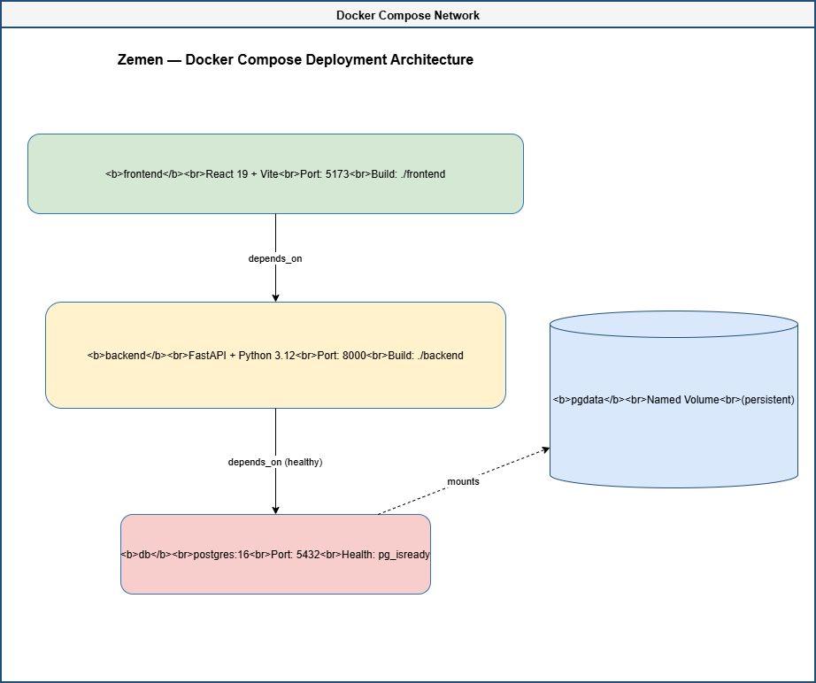 Figure 17: Zemen Deployment Architecture - Docker Compose

9. UML Diagrams

Six UML diagrams were produced for Zemen using PlantUML. Each is documented below with a description of what it shows and the design decisions it captures.

9.1 Class Diagram
The class diagram shows all six database models with their fields and types, the relationships between them, and the six core service classes with their method signatures.

Figure 18: Zemen Full Class Diagram

9.2 Sequence Diagram: Authentication
Shows the full register, login, JWT, authenticated request flow, including the Google OAuth 2.0 path and the alt blocks for invalid credentials and expired tokens.
Figure 19: Authentication Sequence Diagram

9.3 Sequence Diagram: Create and Share Event
Documents the event creation flow (POST /events → snapshot write), participant sharing (POST /events/{id}/share), and how a shared event appears on a participant's calendar.
Figure 20: Create and Share Event Sequence Diagram

9.4 Sequence Diagram: Optimistic Locking and Version Conflict
Shows two editors loading the same event simultaneously. Editor A saves successfully. Editor B receives a 409 Conflict, reviews the field-level diff, and chooses to force-save.
Figure 21: Optimistic Locking - Version Conflict Resolution Sequence Diagram

9.5 Sequence Diagram: Smart Scheduling Pipeline
Documents the full scheduling pipeline from the organiser opening the ranked slot panel, through participant busy-time collection, interval merging, gap finding, candidate generation, and constraint-based ranking, to the result displayed in the UI.
Figure 22: Smart Scheduling Pipeline Sequence Diagram

9.6 Component / Architecture Diagram
Shows the full system component view: the React frontend with its six pages, the FastAPI backend with its eight routers and six service classes, the PostgreSQL ORM models, and the external service integrations.
Figure 23: Zemen System Component Diagram

9.7 Use Case Diagrams
Registered User Use Cases
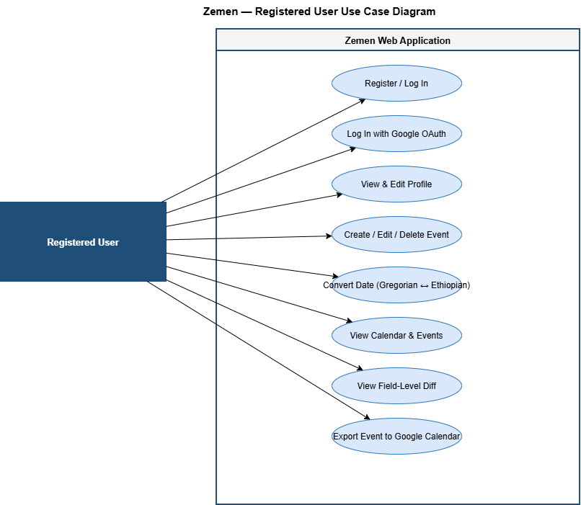
Figure 24: Registered User Use Case Diagram

Admin / Event Owner Use Cases
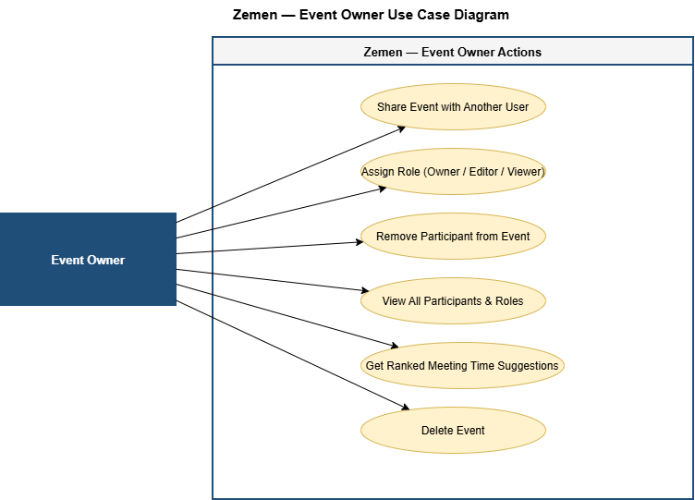
Figure 25: Event Owner Use Case Diagram

10. Feature Implementation

10.1 Ethiopian–Gregorian Date Conversion Engine

The conversion engine is built on top of the ethiopian_date Python library, extended by our DataConversionService wrapper to handle the edge cases the base library does not address.

Edge Case | Rule | Implementation
Ethiopian leap year | Ethiopian year % 4 == 3 is a leap year | Pagume has 6 days; otherwise 5
New Year in non-Gregorian-leap year | Ethiopian New Year = September 12 | Handled in g2e boundary check
New Year in Gregorian leap year | Ethiopian New Year = September 11 | Detected via Gregorian leap year rule
13th month (Pagume) | 5 or 6 days depending on leap year | Validated before conversion; invalid Pagume 6 in non-leap year rejected with 422

10.2 Event Management with Optimistic Locking

Every event carries a version integer, starting at 1 and incrementing with each successful update. The update flow is:

- Client loads event and receives current version (e.g., version=3).
- Client sends update with { version: 3, title: 'New title', ... }.
- Backend compares submitted version against database version.
- If they match: update proceeds, version becomes 4, snapshot is written.
- If they differ: 409 Conflict returned with current_version, your_version, code: 'VERSION_CONFLICT'.

The frontend's EventForm shows the current version and handles the 409 response by displaying a conflict message with options to reload (get latest) or view the diff.

10.3 Field-Level Diff and Version History

Every successful event update writes an EventSnapshot, an immutable record of the event state at that version. The DiffService retrieves two snapshots and compares them field by field:

Field | From | To
title | Team Sync | Team Sync Q2
reminder_minutes | 30 | 60

A plain-text digest listing the changed field names is included in the response (e.g. “Changes: title, reminder_minutes”), providing a concise, human-readable summary of each change set.

10.4 Scheduling Algorithm: 5-Stage Pipeline

The smart scheduling engine runs a five-stage pipeline when GET /events/{id}/rank is called:

Stage | Function | Description
1 | Collect busy intervals | For each participant, query all events in the search window. Each event → (start, end) tuple. Holidays → all-day (window_start, window_end) tuples.
2 | merge_intervals() | Sort all intervals by start. Sweep through, merging overlapping or touching intervals into a minimal non-overlapping set.
3 | find_gaps() | Given merged busy set and window boundaries, identify all free intervals where a meeting could fit.
4 | choose_slots() | Walk each gap; generate all slots of the requested duration, advancing by the full meeting duration at each step.
5 | rank_slots() | Score each candidate slot using the penalty table. Sort by score ascending. Return top N results.

Penalty Scoring Table
Condition | Penalty
Required participant is busy at this slot | Slot excluded entirely (infinite penalty)
Optional participant is busy at this slot | +100 points per conflict
Slot is outside configured work hours | +30 points
Earliness preference | +N points where N = minutes from window start ÷ 10

10.5 Email Reminder System

The ReminderService runs as a Python daemon thread that starts when the FastAPI application boots. Every 10 seconds it:
- Queries all events with reminder_minutes set.
- if the event's reminder window is within the current polling interval.
- Checks the reminder_logs table to see if this event's reminder has already been sent.
- If not: sends the email via smtplib with TLS and writes a log entry.
The daemon=True flag ensures the thread exits automatically when the main process exits, without requiring explicit cleanup.

10.6 Google OAuth 2.0 and Calendar Export

Two separate OAuth flows are implemented:
- Login flow (/auth/google/*): Exchanges authorization code for an ID token; extracts user email; creates or retrieves the user account; returns a Zemen JWT.
- Calendar connection flow (/google/*): Exchanges code for access and refresh tokens; stores them in the users table; enables POST /google/export-event/{id} to push events to Google Calendar.

11. Testing

Zemen has a comprehensive two-tier testing strategy: Pytest for unit and integration testing of algorithms and backend logic, and Postman for end-to-end API integration testing. Together they provide 209 automated test executions, all passing.

11.1 Unit Tests -- Pytest (116 Tests)

Test File | Tests | Coverage Area
test_date_conversion_edge_cases.py | 16 | Ethiopian–Gregorian conversion engine: New Year boundary (Sep 11 vs 12), Pagume leap year (5 vs 6 days), 6 round-trip pairs, all 13 month names, year-boundary dates
test_scheduling_pipeline.py | 15 | Full scheduling algorithm: two-user conflict, fully-blocked window, fragmented interval merging, required vs optional participant handling, sort order, version conflict logic, role permission checks, gap-shorter-than-duration
Additional test coverage | 85 | Authentication, profile, CRUD operations, holiday management, diff computation, reminder deduplication

Figure 26: Pytest -- 116 tests passing with zero failures

11.2 Integration Tests - Postman (93 Tests)

The Postman collection covers all 11 endpoint folders in a top-to-bottom workflow that mirrors real user interactions. It consists of 28 requests containing a total of 93 pm.test() assertions, all passing. The table below shows the number of requests per folder; the Collection Runner reports the full assertion count of 93. The collection is designed to be fully rerunnable without any manual setup between runs.

Folder | Requests | What Is Tested
00 - Health | 1 | Server availability (GET /health)
01 - Authentication | 4 | Register (timestamp email), valid login, wrong password (401), no-token access (401/422)
02 - Profile | 2 | Get profile, update profile
03 - Date Conversion | 3 | g2e (Jan 7 2026 → Tahsas 29 2018), e2g (Meskerem 1 2017), missing param (422)
04 - Events CRUD | 6 | Create, list, get by ID, update (live version fetch), version conflict (409), non-existent (404)
05 - Sharing & Participants | 2 | Share event, list participants
06 - Scheduling | 3 | Conflict detection, slot suggestion, ranked slot results
07 - Event Diff | 1 | Field-level diff between versions 1 and 2
08 - Holidays | 3 | List, create, delete
09 - Google Calendar | 2 | Connection status, connect URL
10 - Cleanup | 1 | Delete test event

Rerunnability Design
- Registration: uses Date.now() in the email address (e.g. test1748300000000@zemen.test) so each run registers a fresh unique user without hitting duplicate email errors.
- Update Event: uses a pm.sendRequest pre-request script that fetches GET /events/{{event_id}} before the PUT, extracts the current version, and stores it as a collection variable. This ensures the version is always fresh regardless of how many updates have been run.
Figure 27: Postman Collection Runner - 93 tests, all passing
12. Challenges and How We Solved Them

12.1 Ethiopian Calendar Edge Cases
The conversion engine required careful handling of three distinct boundary conditions: the New Year date (September 11 vs 12 depending on the Gregorian leap year), the Pagume month length (5 vs 6 days depending on the Ethiopian leap year rule: year % 4 == 3), and round-trip losslessness. We caught several off-by-one errors through the 16 parametrised Pytest tests errors that would have been invisible in manual testing.

12.2 Optimistic Locking and Stale Versions in Postman
The initial Postman Update Event request sent a hardcoded version number (version: 1) that became stale after the first run. This caused all subsequent runs to receive a 409 Conflict. We solved it by adding a pre-request script: pm.sendRequest fetches the current event before the update, extracts the live version, stores it as a collection variable, and the update body uses that value.

12.3 FastAPI Header Validation Cascade Failure
The login endpoint in FastAPI takes email and password as bare function arguments, which FastAPI maps to query parameters. Our initial Postman collection sent a JSON body, receiving a 422 Unprocessable Entity in response. This silently prevented the JWT from being saved, causing every subsequent authenticated request to fail with 401. Once we corrected the login request to send credentials as query parameters, the entire collection passed.

12.4 Interval Merging: Touching Boundaries
The first version of merge_intervals treated touching intervals (e.g., (09:00, 10:30) and (10:30, 11:00)) as non-overlapping and left them separate. This produced a spurious 0-minute free gap between them. The fix was to change the merge condition from strictly less than to less than or equal to when comparing the end of the current merged interval with the start of the next.

12.5 Holiday Integration in the Scheduling Engine
The scheduling engine initially computed busy intervals only from events. When we added holiday support, we needed to inject all-day holiday blocks into the busy set before merging. This required extending busy_intervals_for_user to call a holiday_intervals helper and prepend the results before passing them to merge_intervals. This was an unplanned design change but straightforward to implement because IntervalService was already modular.

12.6 Google OAuth Redirect URI Mismatch
Google OAuth requires exact redirect URI matching between the Google Cloud Console registration and the application configuration. An initial mismatch between GOOGLE_REDIRECT_URI in docker-compose.yml and the registered URI caused 400 errors during the OAuth callback. Resolved by aligning both to http://localhost:8000/auth/google/callback.

12.7 Security Considerations for Future Production Deployment
For a university project, the security baseline is solid. However, for a production deployment, three improvements would be required:
- The login endpoint passes credentials as query parameters, which appear in server access logs. These should move to the request body (form data).
- The default SECRET_KEY fallback in the environment should be removed so the application refuses to start without an explicit environment variable.
- Google OAuth tokens stored in the users table should be encrypted at rest rather than stored as plaintext strings.

13. Conclusion

Zemen began as a straightforward dual-calendar event management application and evolved through the iterative Scrum process and the professor's challenge to exceed CRUD functionality into a technically substantial collaborative scheduling platform.

The three features that most distinguish Zemen from a simple CRUD application are:

- Optimistic locking with version conflict detection, a production-grade pattern that prevents silent data loss in collaborative editing, implemented correctly with atomic version increments, snapshot writing, and a meaningful client-facing recovery flow.
- The five-stage scheduling pipeline, nterval merging, gap finding, candidate generation, and penalty-based constraint ranking, which produces genuinely useful meeting time suggestions that are aware of Ethiopian holidays, participant roles, and work-hour preferences.
- The immutable event snapshot system with field-level diff, which provides the same kind of auditable change history found in professional tools like Google Docs, without external dependencies.

Every deliverable committed to in the approved project proposal was delivered:

Feature | Status
User accounts and profile CRUD | Delivered
Event management with recurrence | Delivered
Holiday data (both calendars) | Delivered
Google OAuth 2.0 login | Delivered
Google Calendar export | Delivered
Email reminders (SMTP daemon) | Delivered
Ethiopian–Gregorian conversion engine (full edge cases) | Delivered
Timezone-aware UTC storage | Delivered
Shared events with owner/editor/viewer roles | Delivered
Optimistic locking and version conflict detection | Delivered
Field-level diff and version history | Delivered
Interval merging and time slot suggestion | Delivered
Constraint-based slot ranking algorithm | Delivered
Figma wireframes | Delivered
UML diagrams | Delivered (6 diagrams + 2 use case diagrams)
Pytest unit tests | Delivered (116 tests, all passing)
Postman integration tests | Delivered (93 tests, all passing)
Docker Compose deployment | Delivered

The codebase is clean, modular, and well-tested. The architecture, three tiers with clear separation of concerns, six focused service classes, and a schema that required zero changes across four sprints demonstrates the kind of upfront engineering discipline that this course aimed to develop.

14. Future Plans

Enhancement | Description | Complexity
Real-time collaboration via WebSockets | Replace the current optimistic locking model with WebSocket-based live updates. Users would see each other's edits in real time without a page reload. | High
Mobile application (React Native) | A React Native version of the frontend would make Zemen far more accessible for everyday use, particularly for Ethiopian users on mobile. | High
Natural language event input | Parse phrases like 'Meet John next Tuesday at 2pm Addis Ababa for 1 hour' into structured event data. Planned in an early proposal draft. | High
Full bidirectional Google Calendar sync | Extend beyond export-only to full two-way sync: changes in Google Calendar reflect in Zemen and vice versa. | High
UI design system | Replace inline CSS with Tailwind CSS or a component library for a consistent, scalable design. | Medium
Recurring event series management | Allow editing a single occurrence vs the entire series, with proper recurrence exception handling. | Medium
Public holiday API integration | Pull live Ethiopian and Gregorian holiday data from an external API rather than relying on seeded data. | Low

